# **Panchamahabhutas**

# **Understanding their role in Wellness**

In the hustle and bustle of modern life, it's easy to forget that we are intricately connected to nature. For centuries, ancient traditions have taught us that the natural world is not just something we live in but a part of who we are. Among these teachings is the profound concept of the **Panchamahabhutas**—the five great elements: **Ether (Akasha)**, **Air (Vayu)**, **Water (Jala)**, **Fire (Teja)**, and **Earth (Prithvi)**. These elements form the very building blocks of our existence, influencing not just our physical bodies but also our mental and spiritual well-being.

## A Journey Back in Time

Imagine being in ancient India, where sages and seers lived amidst lush forests and flowing rivers. They observed nature closely and realized that the entire universe, including the human body, is composed of these five elements. Everything that we are, everything we touch, see, hear, and feel, is made up of a combination of these elements. This understanding became the foundation of Ayurveda, India's traditional system of medicine, which focuses on achieving harmony between these elements to maintain health and wellness.

Let's explore each of these elements and how they play a role in our lives.

### Ether (Akasha) - The Space Within and Around Us

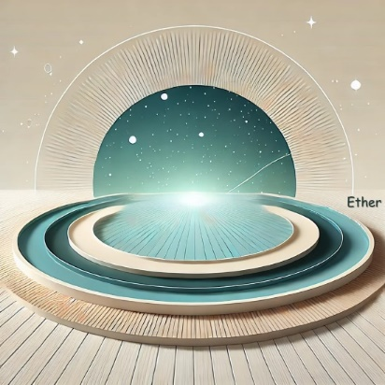Ether, or Akasha, is the most subtle of all elements. It is the empty space that allows everything else to exist. Think about the vast sky above or the space inside a hollow bamboo stem—without this emptiness, there would be no room for anything to grow, move, or breathe.

In the human body, Ether is present in spaces such as the mouth, nostrils, ears, lungs, and even within our cells. Ether represents **freedom** and **expansion**, allowing thoughts to flow freely and creativity to flourish. When Ether is balanced, you feel open-minded, inspired, and connected to the world around you.

However, when there's a deficiency of Ether, you may feel stuck, confined, or mentally rigid. Too much Ether, on the other hand, can make you feel lost or disconnected. Imagine being locked in a small room for days—how stifled you would feel without space to move or breathe!

**Wellness Tip**: To balance Ether, spend time in open spaces, meditate to clear your mind, and practice deep breathing exercises to create space within your body.

### Air (Vayu) - The Breath of Life

Air, or Vayu, is the element of movement and life force. Without air, there is no breath, and without breath, there is no life. Air is the reason our lungs expand and contract, our blood flows, and our thoughts race. It is the element that **fuels movement**, both physical and mental.

The ancient yogis believed that every breath you take is a gift, a reminder that you are alive. But how often do we pause to appreciate our breath? Most of us breathe shallowly, taking in just enough air to survive but not enough to truly thrive.

In Ayurveda, Air governs the nervous system, thoughts, and emotions. When Air is balanced, you feel **light, energetic, and mentally clear**. But when it’s out of balance, you might experience anxiety, restlessness, or even joint pain.

**Wellness Tip**: Practice pranayama (breath control) to regulate your airflow. Spending time in nature, particularly in areas with fresh air, can also help balance this element.

### Water (Jala) - The Source of Nourishment

Imagine walking through a desert, parched and thirsty. The moment you find a cool stream, you feel rejuvenated. That's the power of Water, the element that nourishes, cleanses, and sustains life. In the human body, Water is present in our blood, lymph, saliva, and other bodily fluids. It's no wonder that our bodies are made up of around **70% water**.

Water is the element of **fluidity, adaptability, and emotion**. When water is in balance, you feel content, adaptable, and compassionate. When it’s lacking, you might feel dry, both physically and emotionally—think dry skin, constipation, or even emotional dryness like apathy. An excess of Water can lead to stagnation, causing you to feel sluggish or emotionally overwhelmed.

**Wellness Tip**: Drink plenty of water, eat hydrating foods like fruits and vegetables, and spend time near water bodies to recharge your Water element.

### Fire (Teja) - The Spark of Transformation

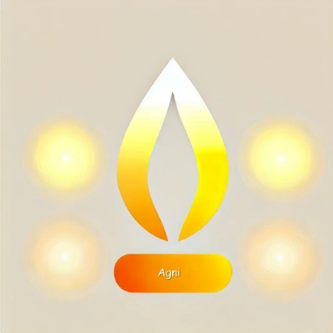Fire is the element of transformation. It turns raw ingredients into a delicious meal, thoughts into words, and dreams into reality. Without Fire, there would be no metabolism, no digestion, no vision, and no passion. It is the **light that guides us**, the heat that keeps us warm, and the passion that drives us forward.

In Ayurveda, Fire is responsible for digestion and metabolism. A balanced Fire element means you have strong digestion, clarity of thought, and the **courage to pursue your goals**. But if your Fire is too strong, you may feel angry, irritable, or overheated. On the flip side, if it’s too weak, you might feel lethargic, have poor digestion, or lack motivation.

**Wellness Tip**: Balance your inner fire by eating foods that are neither too hot nor too cold, practicing sun salutations, and spending time in the sunlight.

### Earth (Prithvi) - The Ground Beneath Your Feet

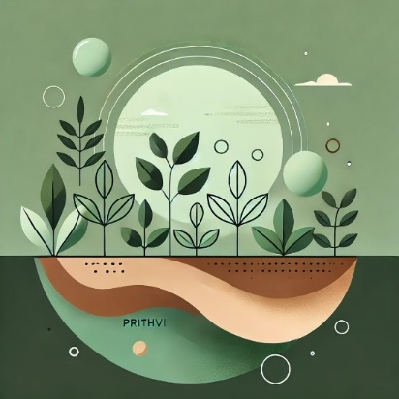Earth is the element of stability, strength, and support. Imagine a towering tree with deep roots—it can withstand storms because it is firmly anchored in the earth. Similarly, when the Earth element in our body is strong, we feel **grounded, secure, and stable**.

The Earth element is present in our bones, muscles, and tissues, providing structure and form. It’s what keeps us rooted when life gets overwhelming. However, too much Earth can make you feel heavy or sluggish, while too little can leave you feeling ungrounded or insecure.

**Wellness Tip**: Spend time barefoot on the ground, eat root vegetables, and practice grounding yoga poses like Mountain Pose or Tree Pose to strengthen your connection with the Earth element.

## Integrating the Five Elements into Your Life

Now that we've explored the Panchamahabhutas, it’s clear that achieving wellness is about balancing these five elements within us. Whether it’s through diet, lifestyle, or mindful practices, we can align ourselves with nature’s rhythms.

For instance:

* Start your day with **deep breathing exercises** to enhance your Air element.
* Drink a glass of warm water with lemon to activate your Fire and Water elements.
* Practice yoga or tai chi to connect with your Earth element.
* Meditate to create space for the Ether element within your mind.

## The Panchamahabhuta Diet: Eating in Harmony with the Elements

In Ayurveda, diet plays a crucial role in balancing the Panchamahabhutas. Here's a simple guide:

* **Ether**: Focus on foods that create space within the body, like light soups and herbal teas.
* **Air**: Include warm, grounding foods like cooked vegetables and grains to balance the lightness of Air.
* **Water**: Eat hydrating foods like cucumbers, watermelons, and leafy greens.
* **Fire**: Balance your inner fire with cooling foods like cucumbers, mint, and yogurt.
* **Earth**: Enjoy root vegetables, nuts, and seeds to stay grounded.

## Conclusion: Embracing the Wisdom of Panchamahabhutas

The concept of Panchamahabhutas is a reminder that we are not separate from the world around us. By understanding and balancing these five elements, we can lead healthier, more fulfilling lives. In a world that often feels chaotic, reconnecting with these ancient principles can ground us, nourish us, and bring us back to the basics of holistic wellness.

So, the next time you feel off balance, ask yourself: Which element do I need to nourish today? Whether it’s taking a walk in nature, drinking more water, or simply breathing deeply, you have the tools to bring harmony back into your life.

**About Sahaja Swasthaya**

We are a premier wellness center in Bengaluru, committed to fostering holistic health through integrative approaches. Established under the expert guidance of Prof. Dr. B.T. Chidananda Murthy, a distinguished leader and former Director at the National Institute of Naturopathy & Central Council for Yoga & Naturopathy, AYUSH Ministry, our mission is to blend time-tested natural healing traditions with the advancements of modern science. Our programs are designed to promote physical, mental, and spiritual well-being by focusing on personalized care. By combining the wisdom of ancient practices like yoga and naturopathy with contemporary health insights, we aim to empower individuals towards a healthier lifestyle.

© 2024 Sahaja Swasthaya. All Rights Reserved.